Exit Exam

ANSWER KEY and SCORING SCALE

How to Tip

Points____1____

- What is considered standard tipping percentage for services received (i.e. Restaurant bill, hair cut services, transportation services.)
- %10
- %15
- %25
Points____1____

- If your dinner bill at a restaurant comes out to $73.60 what should the standard tip be?
- $15.04
- $14.60
- $11.04
Points____1____

- In which situation is it appropriate to tip?
- At restaurant
- At Bar
- Taxi/Car Service
- All of the above
- Only A and B

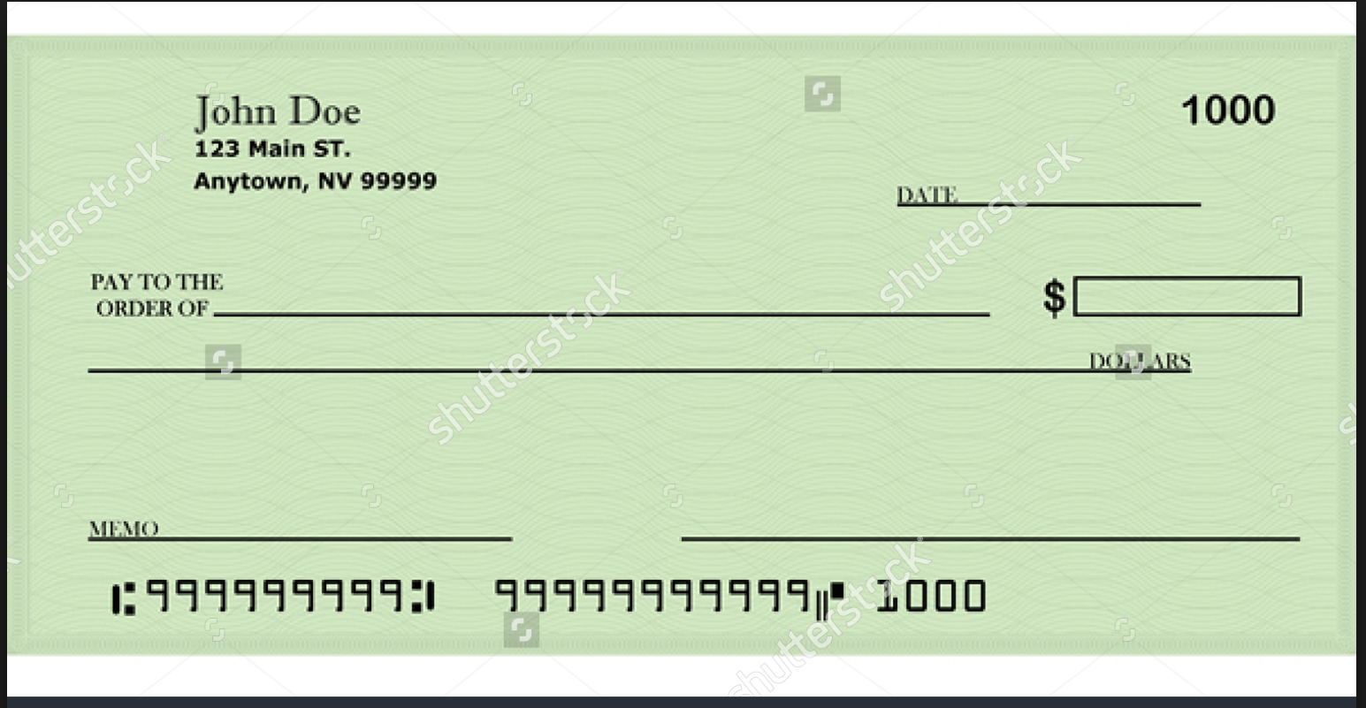

Points____2____

4. Using the check above, pay your electric bill to SDG+E for $67. Your account number is, 14387200.

Points____2____

- Using the blank envelope above, send your SDG+E check.
SDG+E Electric
1482 Main Street
BlueBalls, VA 09211
- Be sure to write your return address and place stamp in the appropriate place*

Credit
Points____1____

- What is a bad credit score?
- 750
- 500
- 350
Points____1____

- What do you need credit for?
- To rent an apartment
- To rent a car
- To have an account with cable television, gas/electric, and cell phone services.
- Potential employment
- All of the above
- Just A and C

Points____1____

- How do you maintain good credit?
- Pay your bills on time, every time
- Don’t get close to your credit limit
- A long credit history will help your score
- Only apply for credit that you need.
- A and E
- All the above
Points____1____

- Circle True or False

Your credit information can be a factor in whether or not you can rent a nice apartment, how much you pay for insurance or whether or not you can get a job
Points____1____
True False

Sewing
Points____2____

- Thread a needle and sew a button onto the blank space below.

Points____1____

- Circle True or False
Sewing will come in handy when I have a hole in my jeans, a button that fell off my favorite jacket, or when there is a tear in my bedding.

True False

Points____1____

- Sewing is NOT an effective way to sew up a cut on your body, also known as suturing.
True False

Budgeting

Since budgeting allows you to create a spending plan for your money, it ensures that you will always have enough money for the things you need and the things that are important to you. Following a budget or spending plan will also keep you out of debt or help you work your way out of debt if you are currently in debt.

Points____4____

- In one month you make $1,762.50 after taxes (net income) are taken from your paychecks (gross income). Here are your monthly bills.
Bills Amount Due Date

  - Rent 550 1st
  - Electrical 50 15th
  - Cell Phone 50 24th
  - Water 20 1st
  - Car insurance 90 15th
  - Health insurance 150 26th
  - Cable TV/internet 100 5th

Other Necessities

Entertainment 200
Food 400
Gas 200 Total bills/other necessities $___1800___.______

Do you make enough money to pay all your monthly bills and other necessities? Circle your answer

Yes No

**If no, besides making more money, what could you do to live within your means***

________________________________________________________________________________________________________
________________________________________________________________________________________________________

Points____1____

- Considering each paycheck you get, approximately 25% of your gross wage is taken for various taxes, how much do you make a month before taxes are taken out?
  - $1,775.35
  - $2,068.49
  - $1,788.55
  - $2,350.10
Points____1____

- Now that you know how much you make a month, how much do you take home after taxes (net wage) every two weeks?
$881.25
Points____1____

- *Apply the answer you got from #13 into the blank space.
  - If you know you make _______$2,350.10______ a month and you work 40 hours a week, how much do you make an hour before taxes (gross wage) are taken?

___$14.68_________________________________________________________________________________________

Modern Etiquette
Points____1____

- When is appropriate to write a “Thank You” note?
  - When someone gives you a gift
  - After an interview for a job
  - Anytime someone was thoughtful towards you
  - Never they are outdated
  - A, B, and C
Points____3____

Using the proper format, in your own words, write a “Thank you” note to your parents.

___Dear XXX,_____________________________________________________________________________

____________XXXXXXXXXXXXXXXXXXXXXXXXXXXXXXXXXXXXXXXXXXXXXXXXXX__

_XXXXXXXXXXXXXXXXXXXXXXXXXXXXXXXXXXXXXXXXXXXXXXXXXXXXXXXXXX__

_XXXXXXXXXXXXXXXXXXXXXXXXXXXXXXXXXXXXXXXXXXXXXXXXXXXXXXXXXX__

____________________________________________________________________________________________

____________________________________________________________________________________________
Love,
______XXXXXXXX__________________________________________________________________________

____________________________________________________________________________________________

____________________________________________________________________________________________

____________________________________________________________________________________________

____________________________________________________________________________________________

____________________________________________________________________________________________

____________________________________________________________________________________________

____________________________________________________________________________________________

____________________________________________________________________________________________

Points____3____

- When staying at someone’s home as a guest, circle the things you should do to be the best houseguest you can be.

  - Pick up after yourself

  - Open the fridge and eat whatever you’d like.

  - Make your bed

  - Leave your clothes in the bathroom

  - Offer to buy dinner during your staying

  - Alienate yourself from the people living there

  - Bring an unexpected guest with you

  - You should offer to: Help cook; set the table and do the dishes; drive everyone around in your car

  - Leave the place as clean as possible when you go

  - Stay longer than agreed upon

Moving

True or False
Points____1____

18. When you move you need to notify the post office and your monthly debt collectors.

True False
Points____1____

19. If you've moved cities, it's important to make sure you're on the voter's registration for your local area. You should also make sure you've updated all important files and documents with your new address.

True False
House Duties

Points____3____

20. List, in order, the major steps to starting laundry to completing laundry.

1.__Sepreate darks and white ________________________________

2.___Load the washer_____________________________________

3.______Add Soap and hit start________________________________

4.___ Transfer to the dryer _____________________________________

5.____ Clean lint catcher and hit start _______________________________

6._______ Fold and Hang up clothes___________________________

Points____1____

21. Assuming there is normal use of your sheets, how often do you need to wash them?
a. Daily
b. Every other month
6/6 c. Bi-Monthly
d. Never because my mom will do it

Points____1____

22. How often should you clean your bathroom?

a. Daily
b. Weekly
c. Monthly
d. Never because who really cares

Points____1____

23. How often do you replace your toothbrush?

a. Daily
b. Weekly
c. Monthly
d. Never because I don’t need to actually brush my teeth

True or False

Points____1____

Car Stuff

24. How often are you required by law to register your car?

- Twice a year
- Once a year
- Only when you buy the car
- Once every Five years

Points____1____

25. How often should you typically change the oil in your car?

- Change your car's engine oil every three months, or 3,000 miles.
- Change your car's engine oil every six months, or 10,000 miles.
- Change your car's engine oil every six months, or 3,000 miles.
- Change your car's engine oil every twelve months, or 6,000 miles.

Points____1____

26. What happens if you receive a traffic ticket and do pay it?

- Your driver’s license gets suspended.
- Your vehicle registration will be suspended.
- You will get hefty fines.
- Your future insurance premiums will be REDUCED
- All of the above
- Only A, B,C

True or False

Points____1____

27. In most states, it's not a felony hit-and-run if one leaves the scene of an accident that resulted in property and personal damage.
True False

Points____1____

28. If tire pressure is too low, then too much of the tire's surface area touches the ground, which increases friction between the road and the tire. As a result, not only will your tires wear prematurely, but they also could overheat. Overheating can lead to tread separation (A.K.A blowout) and a nasty accident.
True False

Points____2____

29. Where can you find the information about how much air should be in your tires?
A. On your cars dashboard
B. On the sidewall of each
C. On your Drivers License
D. None of the above
E All of the above

Lets get physical!!!!!!

In this section, write out your answer first. Once you have written your answer, you will than be playing out these situations. Supplies will be provided. No one will be helping you.

Points____2____

30. The house is on FIRE!!
One of your roommates left a candle burning and left for work! The pesky house pet kicked off a piece of mail and it landed in the flame. Now the curtains are bellowing with flames!!! What do you do????
Fire Extinguisher
STEP 1: PULL
Pull the pin. This will also break the tamper seal.
•
STEP 2: AIM.
Aim low, pointing the extinguisher nozzle (or its horn or hose) at the base of the fire.
Note:
Do not touch the plastic discharge horn on CO2 extinguishers; it could get very cold and may damage skin.
•
STEP 3: SQUEEZE.
Squeeze the handle to release the extinguishing agent.
•
STEP 4: SWEEP.
Sweep from side to side at the base of the fire until it appears to be out.

Points____2____

31. Your girlfriend came over today and left a surprise for you in the bathroom! The house you currently rent is an older house and the piping is not as good as most homes. Your girlfriend isn’t use to the weak pipes and used too much toilet paper….now there is water flooding the house. Everything this water touches could be destroyed!!! What do you do????
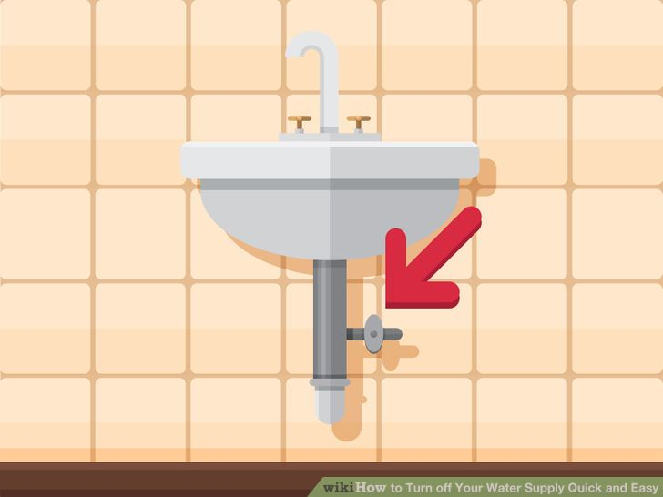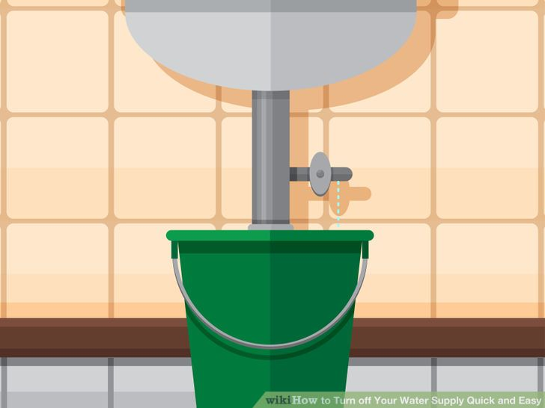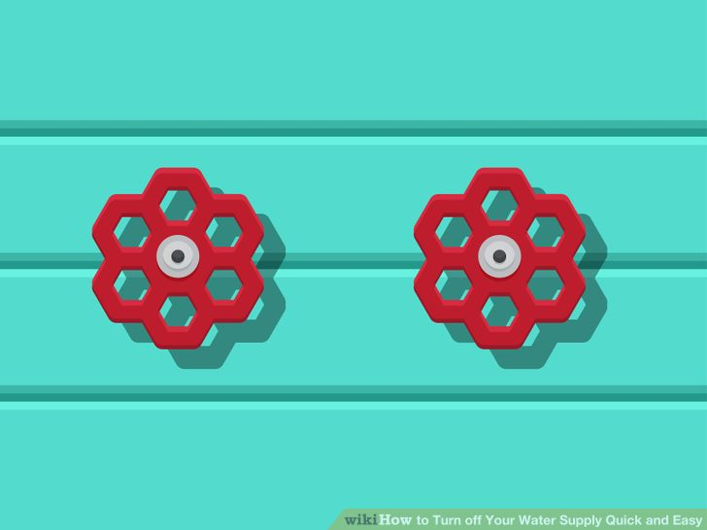

Points____2____

32. You are in your room playing a video game. Your roommates are cooking and jamming on their musical instruments when….BAM….it goes dark….everything in the house has turned off, including your video game….what do you do?????
- Turn off the light switches and unplug appliances in the room that has lost power.
- Find your circuit breaker box and open the cover.
- Locate the tripped breaker. ...
- Reset the breaker by moving it to the full "off" position and then back to "on." ...
- Identify and correct the malfunction before resetting the breaker.

Points____2____

33. Your sleeping soundly and your room starts shaking, things are falling off the walls, and you quickly realize you are in the middle of an earthquake. You run to the nearest doorframe to stand in and within a few seconds the earthquake is done. What do you do turn off to ensure the safety of your home?

HOW TO TURN OFF GAS AFTER AN EARTHQUAKE:
- Turn the valve tang (the flat metal bit that fits in your wrench) 90 degrees so it is crosswise to the pipe.
- Once you shut the gas off, you will have to wait for your utility professional to turn it back on.
- You should only turn off your natural gas if you suspect a gas leak.

Grading Scale
A= 46-51
B= 41-45
C= 36-40
D= 31-35
F= 0-30

